**Project Specification Document**

**1.1 Project and Developer details**

The main objective of this Application is to managed the details of Bank, Accounts, Customers, Transactions, Internet Banking. The purpose of this application to reduce the manual work for managing Accounts, Banks, Transaction, and customers and track all the details through this Application “ICIN banking”. This Application have two views Admin and Customs, Admin have authorities to Approve Transactions, Cheque Book request Etc. User Can create account and perform deposit and withdraw operation.

**A) Admin**

* Approve the Cheque Book Request
* Approve Transaction
* Manage Blocked Account
* Enable net Banking
* Block Threat Accounts
* **Approve the Cheque Book Request**: Admin have below list of requests for cheque book request and have authority to approve the cheque book request:
* **Approve Transaction**: Admin have below list of requests for Approve Transaction and have authority to unblock the user
* **Manage Blocked Account**: Admin have below list of requests for Manage Blocked Account and have authority to unblock.
* **Enable net Banking**: Admin have below list of requests for Enable net Banking and have authority to provide permission for net banking:
* **Block Threat Accounts**: Admin have below list of requests for Block Threat Accounts and have authority to block any user:

**B) User**

* View My Account:
* Manage Cheque Books
* Passbook
* Net Banking
* Deposit
* Withdrawal
* My Profile
* **View My Account**: This Option Show the all-Current details like username, account number, Balance, cheque Book status, net backing status etc.
* **Manage Check Book**: User Request for check Book and See the details and status of cheque book. Based on account type and once admin approve request user have its own cheque book.
* **Passbook**: Initial User passbook is empty, when user perform any transaction that details are appear in passbook.
* **Net Banking**: User can request for net banking and its pending for approval from admin side:
* **Deposit**: User can Deposit amount in his **primary or Saving** account.
* **Withdraw**: User can withdraw amount in his **primary or Saving** account.
* **My Profile**: Using this option user can view there details as well update the password:

**1.2 Developer Details:**

We have developed **ICIN Banking Application** in spring boot rest Api and Angular JS. The main objective of this Application is to manage the details of Bank, Accounts, Customers, Transactions, Internet Banking.

**2.Sprint Planning:**

**Task1: Admin Module: In the Module Admin perform below task:**

* Approve the Cheque Book Request
* Approve Transaction
* Manage Blocked Account
* Enable net Banking
* Block Threat Accounts

**Task 2: Approve the Cheque Book Request**: Admin have below list of requests for cheque book request and have authority to approve the cheque book request:

**Task 3: Approve Transaction**: Admin have below list of requests for Approve Transaction and have authority to unblock the user

**Task 4: Manage Blocked Account**: Admin have below list of requests for Manage Blocked Account and unblocked accounts, have authority to unblock and block the account

**Task 5: Enable net Banking**: Admin have below list of requests for Enable net Banking and have authority to provide permission for net banking:

**Taks 6: User Module: In this Module user perform below task**

* View My Account:
* Manage Cheque Books
* Passbook
* Net Banking
* Deposit
* Withdrawal
* My Profile

**Task 7: View My Account**: This Option Show the all-Current details like username, account number, Balance, cheque Book status, net backing status etc.

**Task 8: Manage Check Book**: User Request for check Book and See the details and status of cheque book. Based on account type and once admin approve request user have its own cheque book.

**Task 9: Passbook**: Initial User passbook is empty, when user perform any transaction that details are appear in passbook.

**Task 10: Net Banking**: User can request for net banking and its pending for approval from admin side:

**Task 11: Deposit & Withdraw**: User can Deposit and Withdraw amount in his **primary or Saving** account.

**Task 12: My Profile**: Using this option user can view there details as well update the password:

**3. Flowchart:**

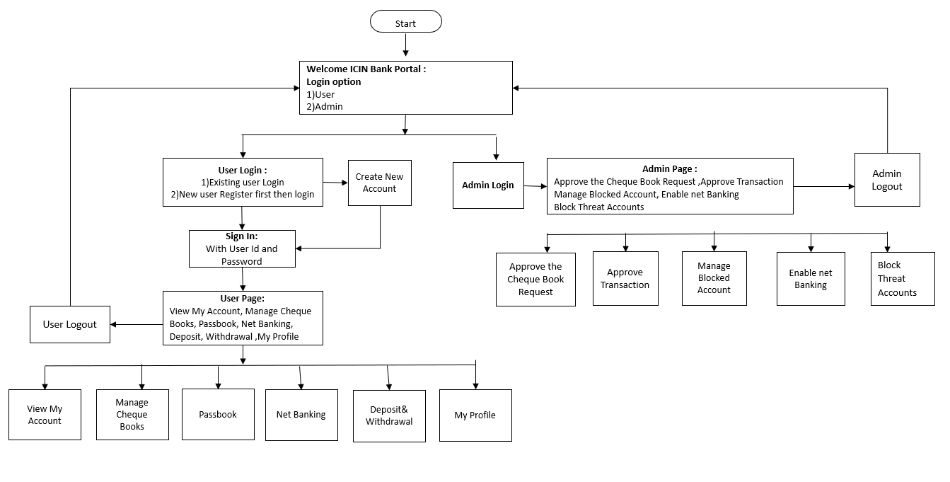

**4. Core concepts used in the project Concepts used in developing the application are**

**Front-End:** HTML, CSS, Angular JS, Bootstrap, JavaScript  
**Server-side:** Spring Boot Rest API  
**Back-end:** MYSQL, Hibernate.

**IDE**: Spring tool suite 4, Node JS

**5**. **Links to the GitHub repository to verify the project completion**

[**https://github.com/ChandanMallick302/Projects/tree/main/Phase-VI/ICIN-Online-Banking**](https://github.com/ChandanMallick302/Projects/tree/main/Phase-VI/ICIN-Online-Banking)